6A^{th} Grade: Unit 6, Lesson 5

- Determine the sign of the sum for each of the expressions in the table.
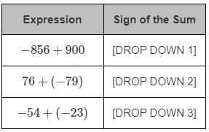
Negative
Negative
Positive

- In the expression -5 + (-9), describe the process of finding the sum using integer chips.

The signs of the addends indicate that there is no need to add integer chips in an integer chip model to create a zero pair.

- What is the additive inverse of -26?

26

- What is the sum of -26 + (-11)?
-37

- Will the expression -438 + 291 result in a positive or negative sum?

Negative Sum

- Find the sum of -441 + (-329).

-770

